Report
Where you can find Code coverage Report?
The code coverage report can be found in “Calculator/htmlReport” in the Calculator Project root directory.
Where You can Find Solutions to the unit test code with test cases passing or not?
You can find the file in the calculator test report of root directory.
The Picture of code coverage report as below.

Class Code Coverage Report with most of the common cases testing all corner cases and all functionalities written in the Calculator.java class in src directory.

Covered addition and subtraction.
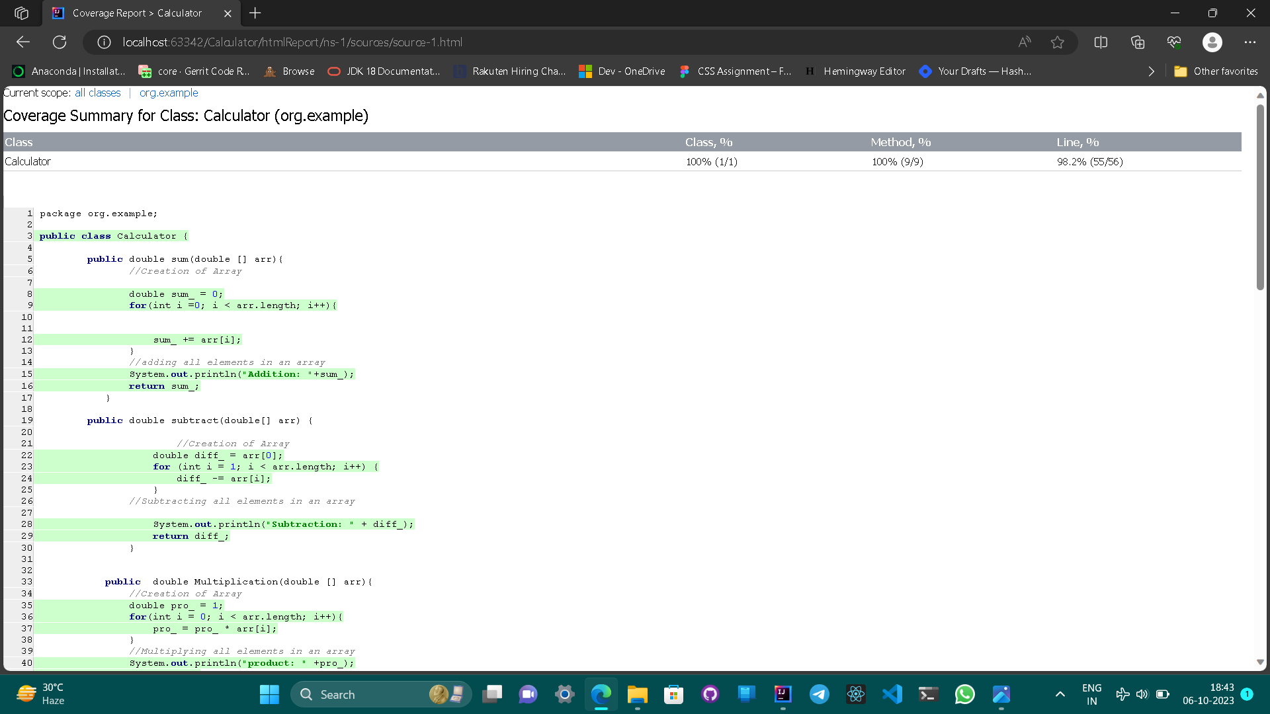
Covered Multiplication cases.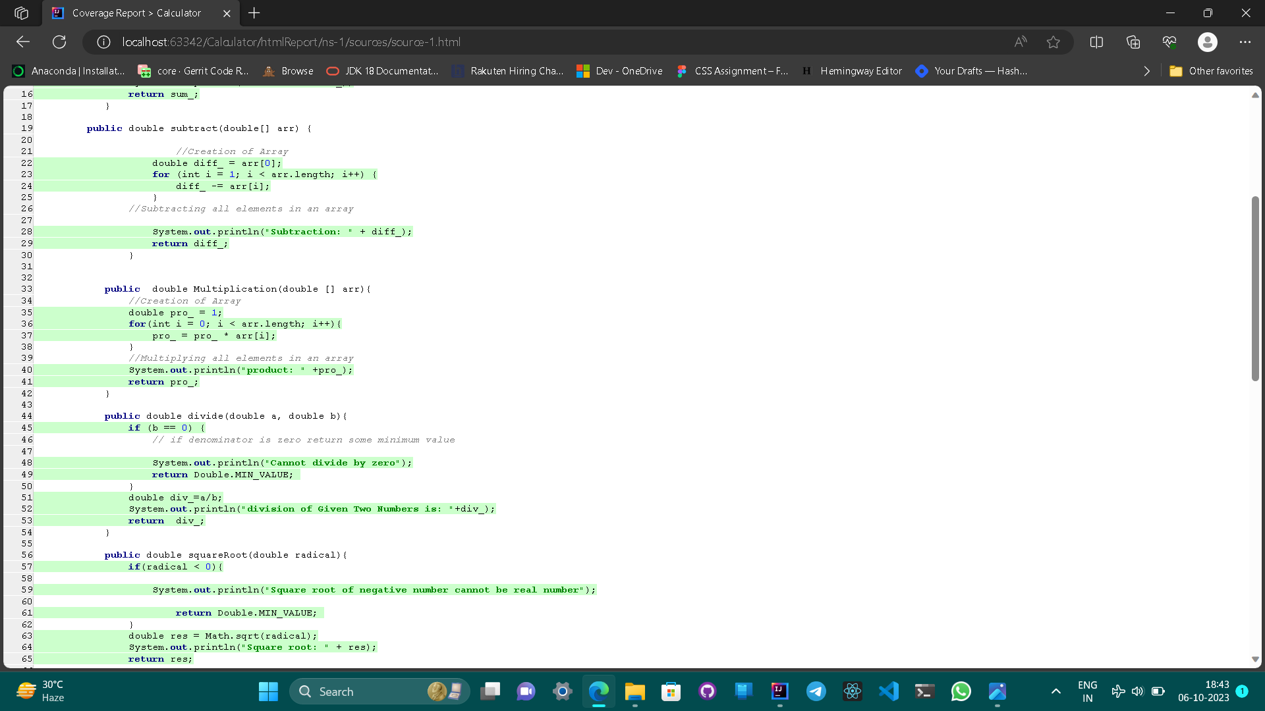
Covered division cases.
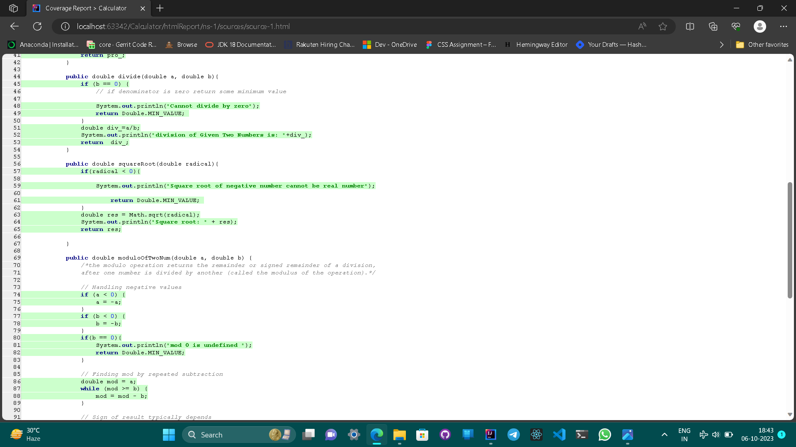

Covered all of modulo by subtraction method except the if(a<0){ return -mod;} as the method converts the input a if it is less than 0 to a positive so it can’t touch this case if it has to be covered than store the value in another value and return the modulo by comparing it.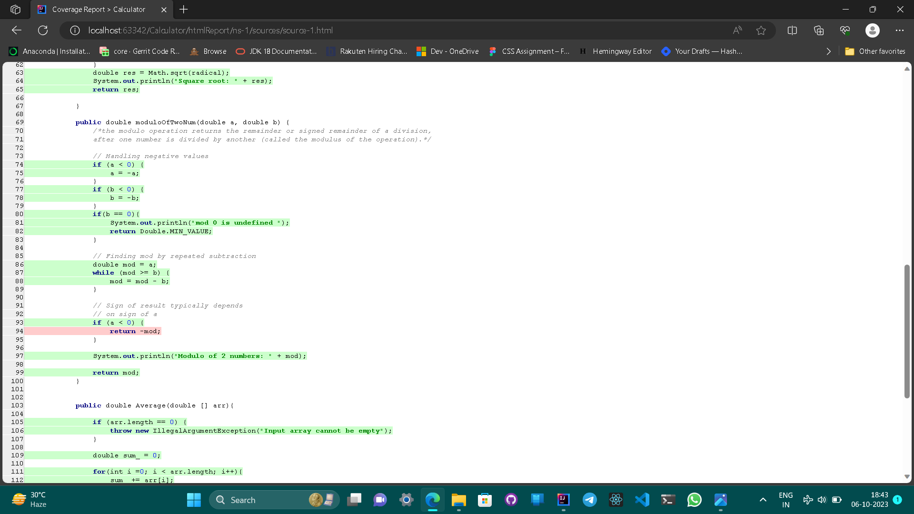
Covered all cases of Averages
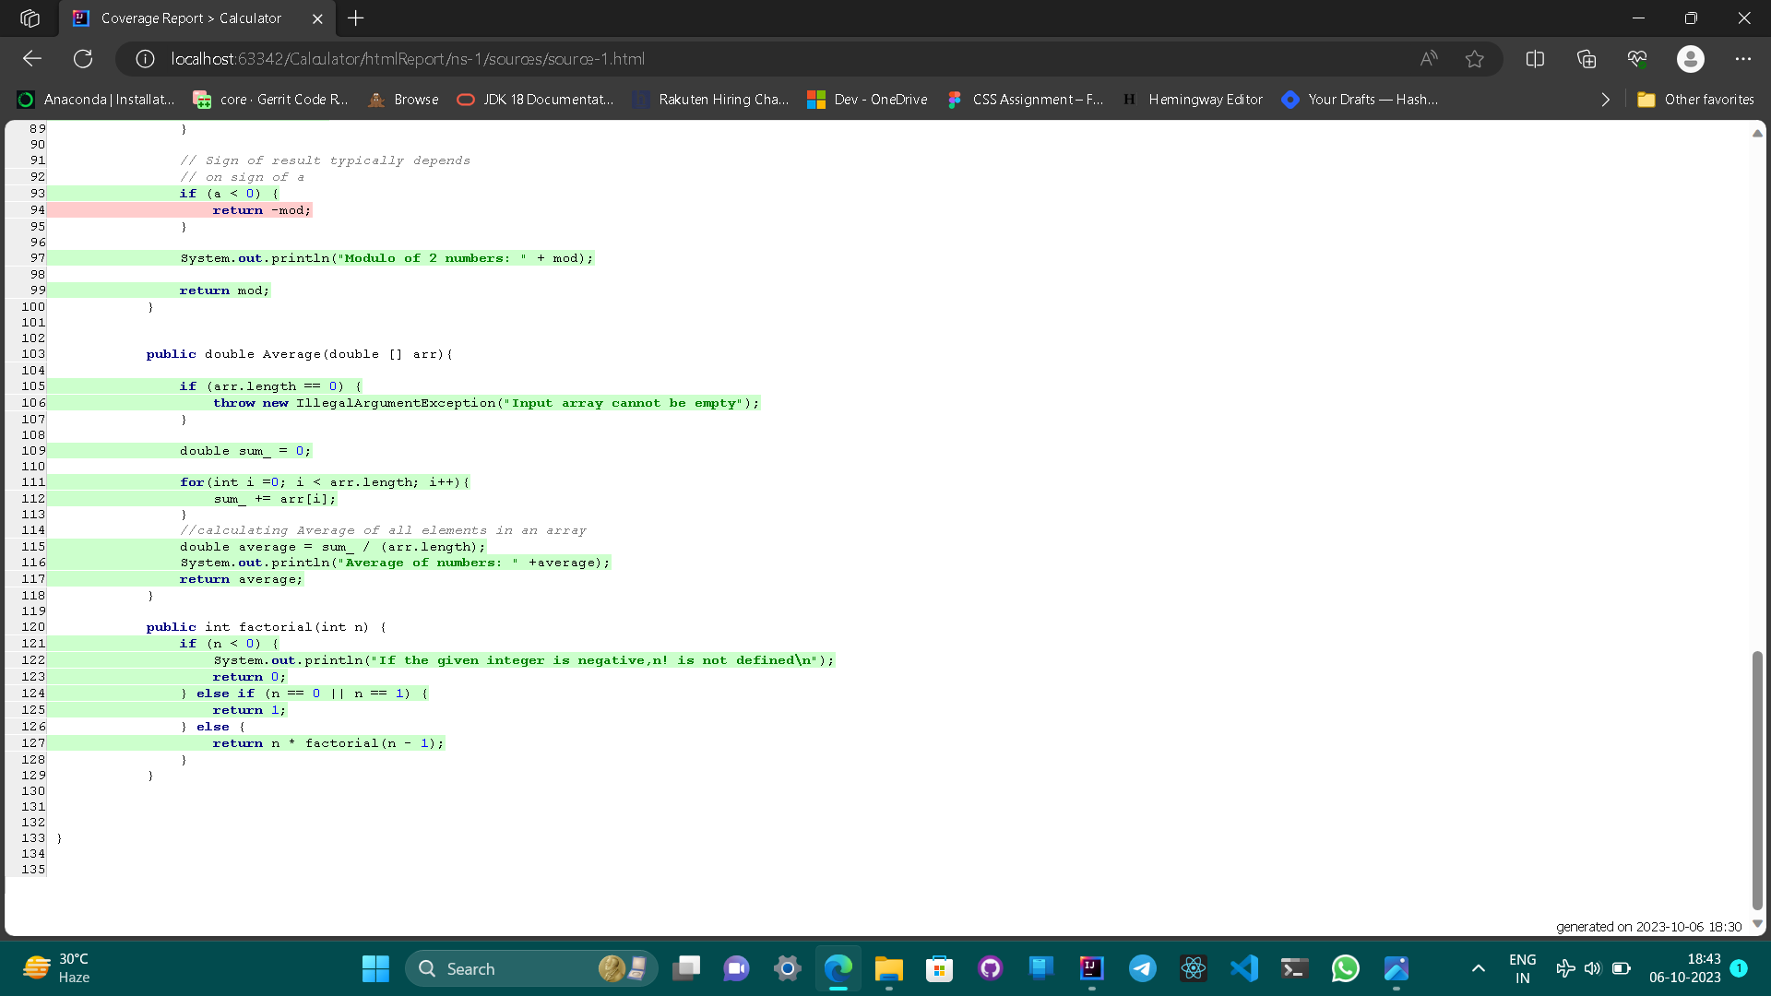

The Test cases are written using JUnit-4 version to test the code.

Basic unit test for addition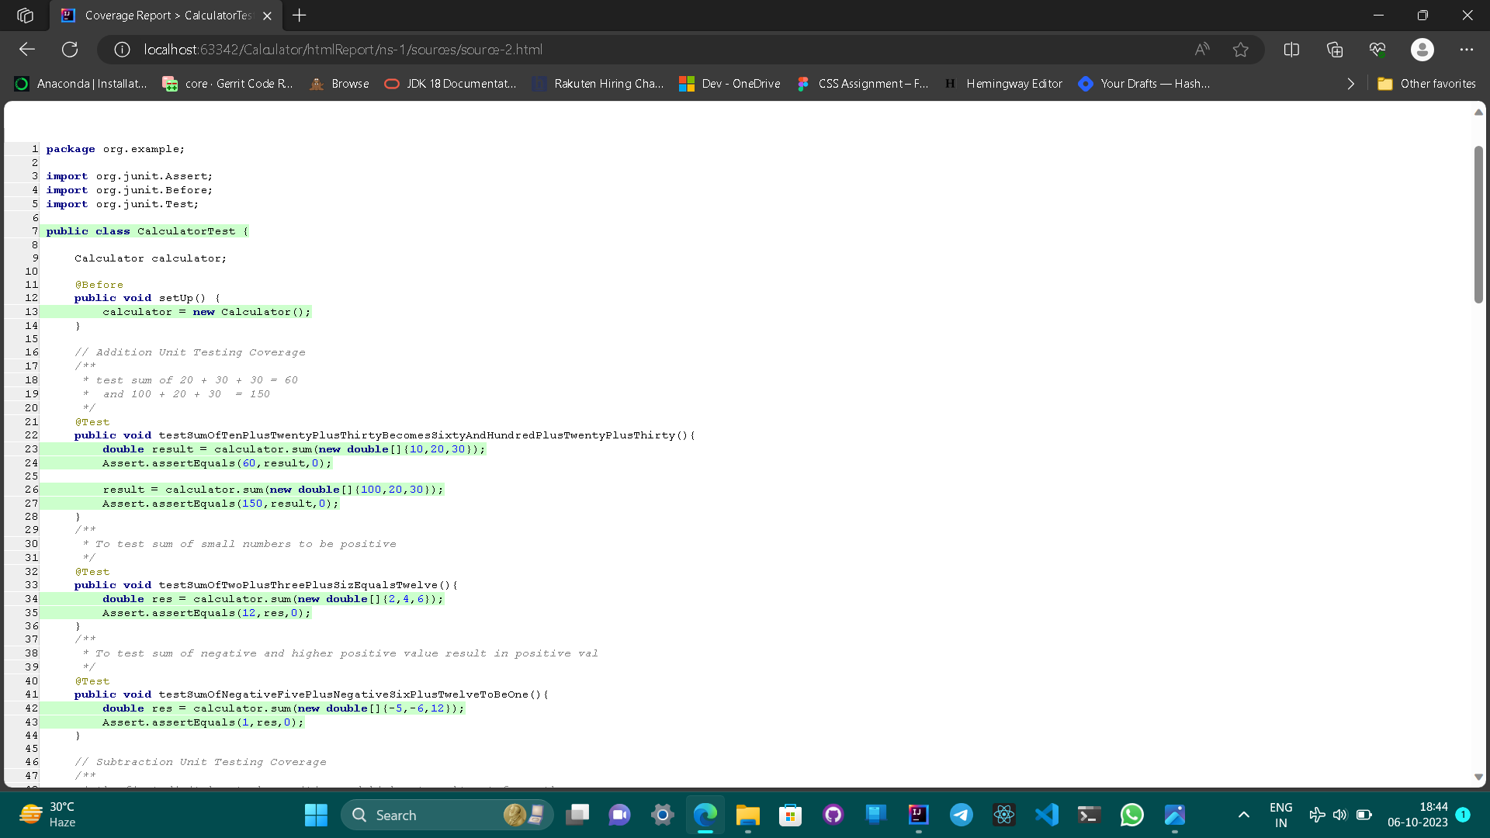
Basic unit test for subtraction, multiplication.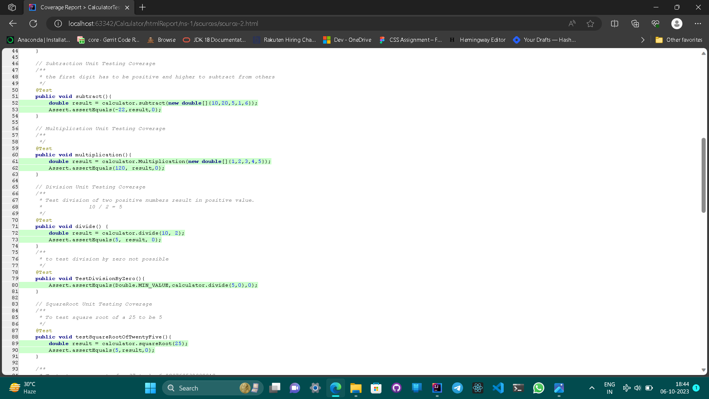
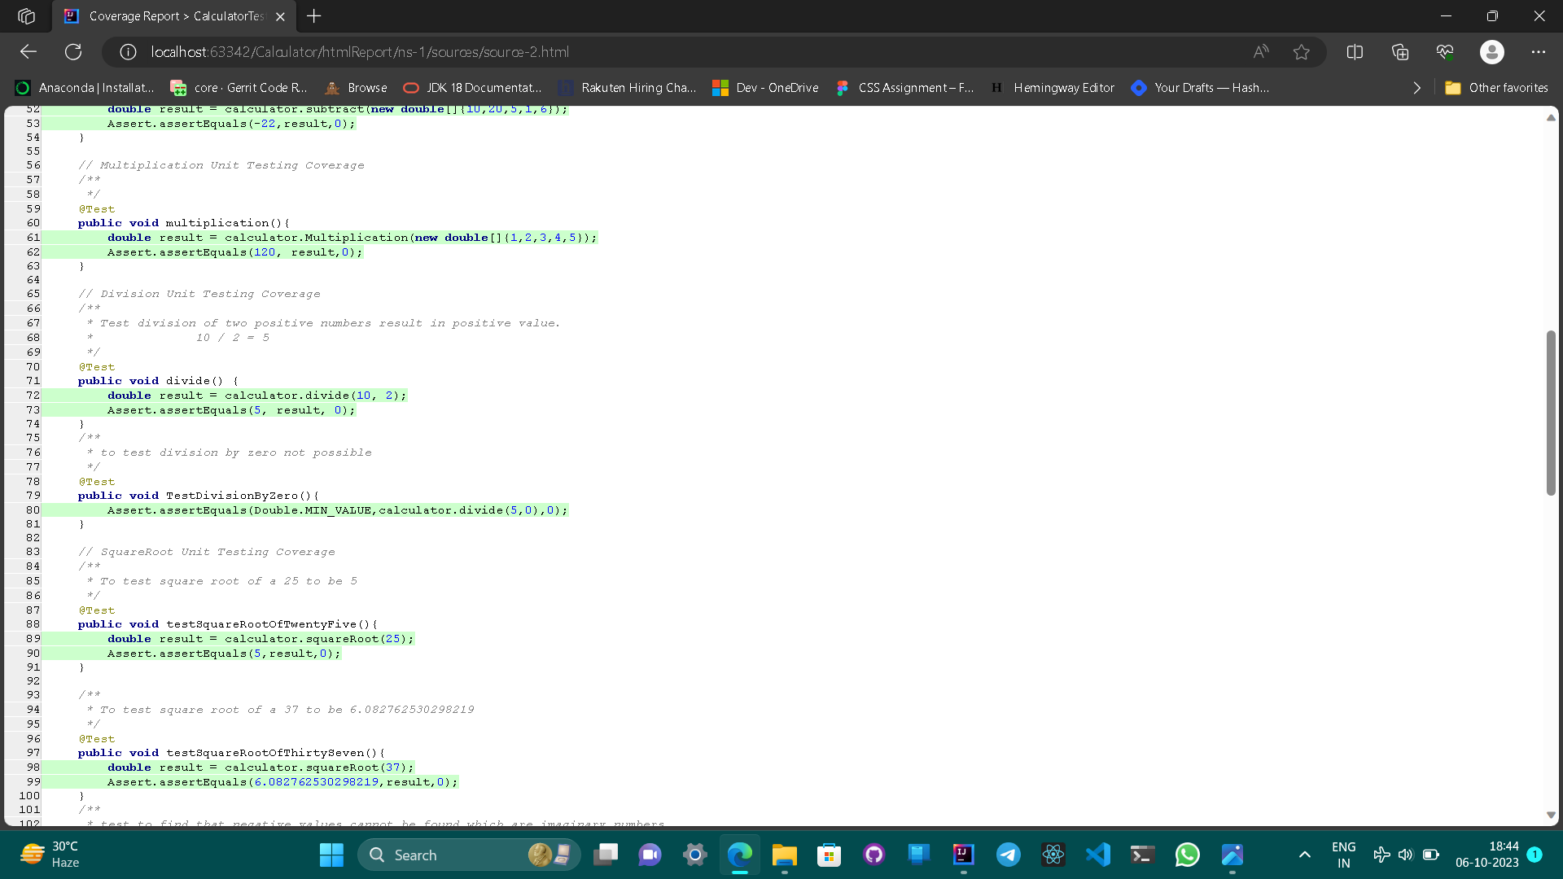
Basic unit test for division.
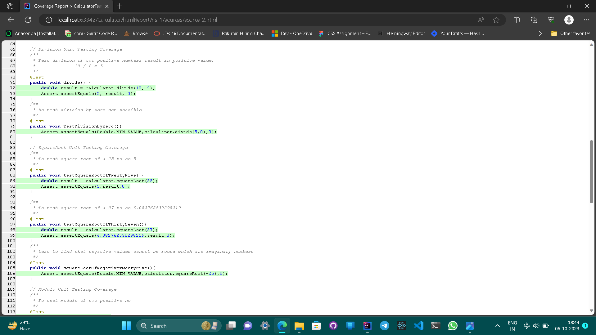

Basic unit test for square root of numbers testing all edge cases.
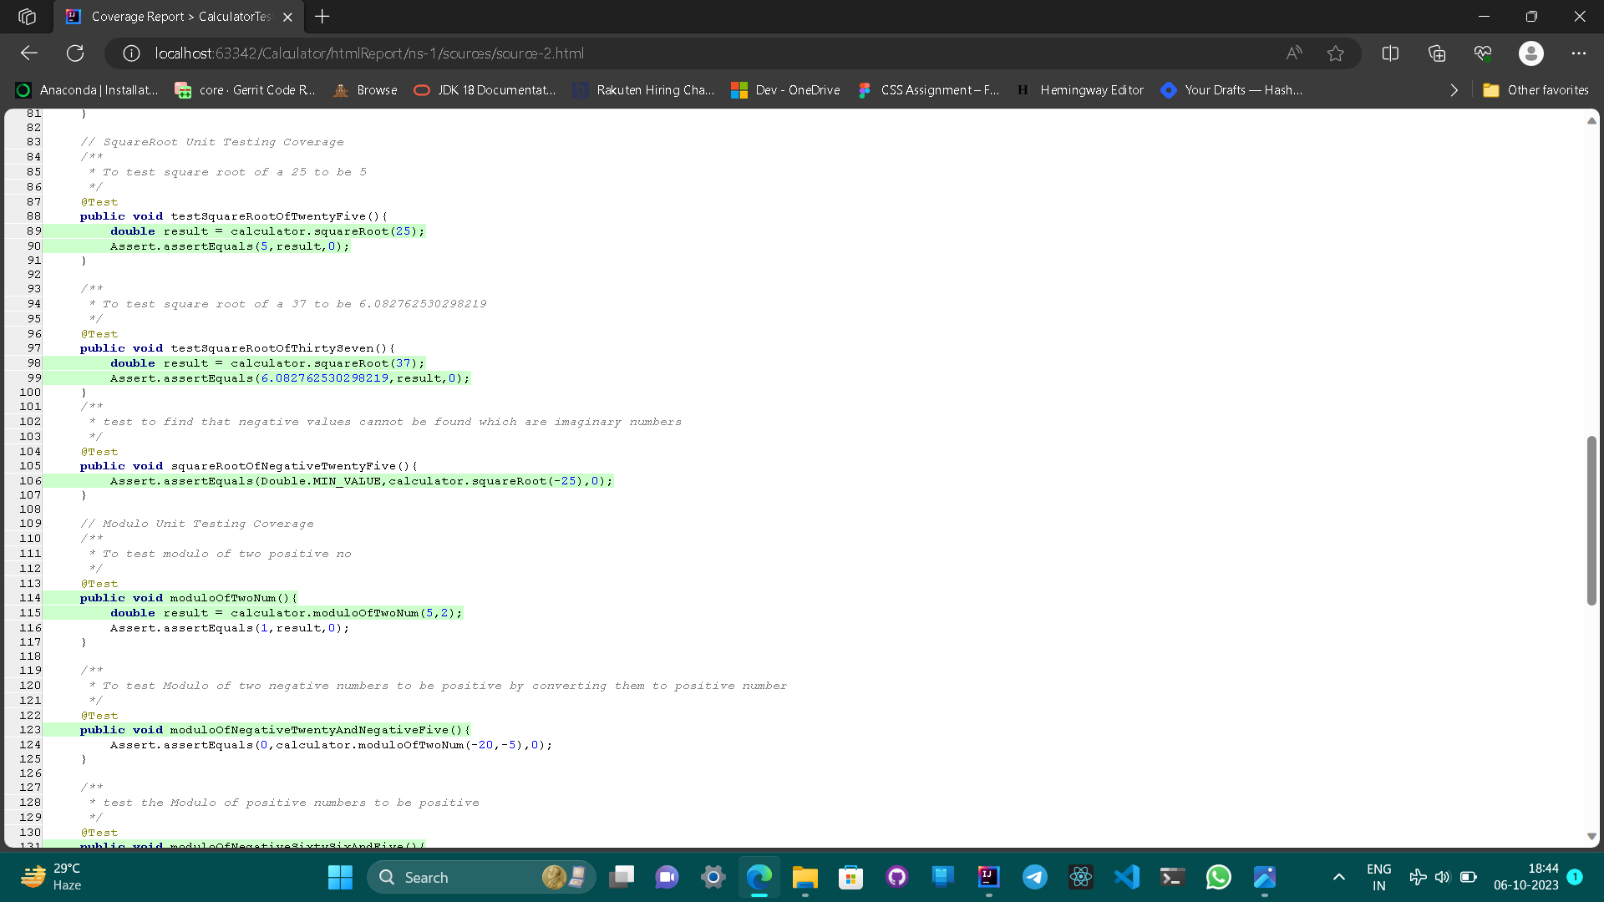

Basic unit test for Modulo of numbers testing all edge cases.
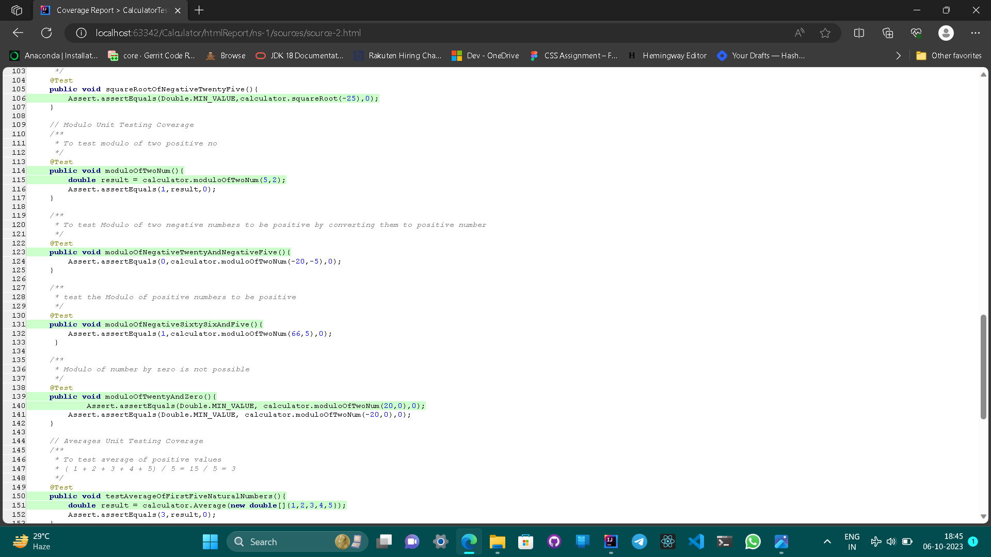
Basic Unit test of average of no number, and more than two positive and negative numbers.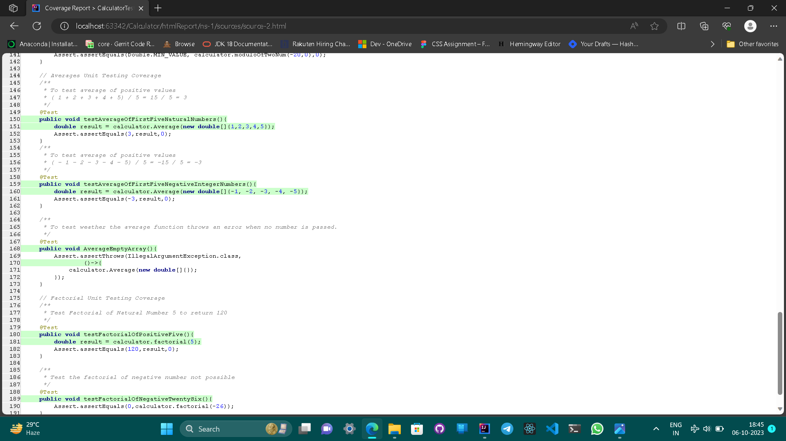

Basic unit test for Factorial of numbers testing all edge cases.